Dis-Eur-**Czech Republic: Moravia-Neolithic-**4 600 - 4 400 Years BCE- **Těšetice-Kyjovice**  
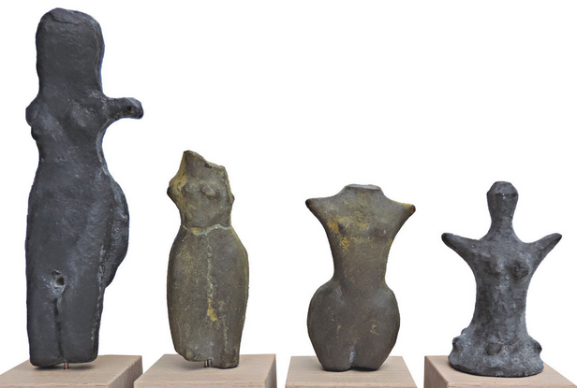

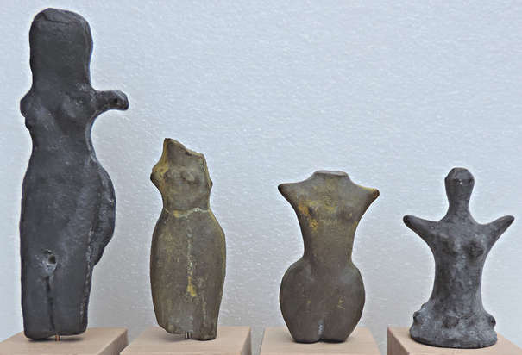 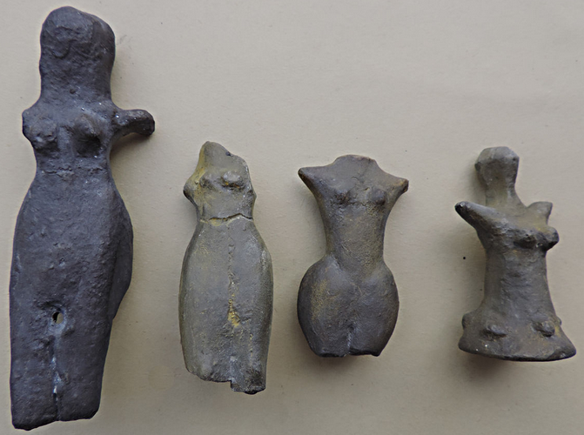 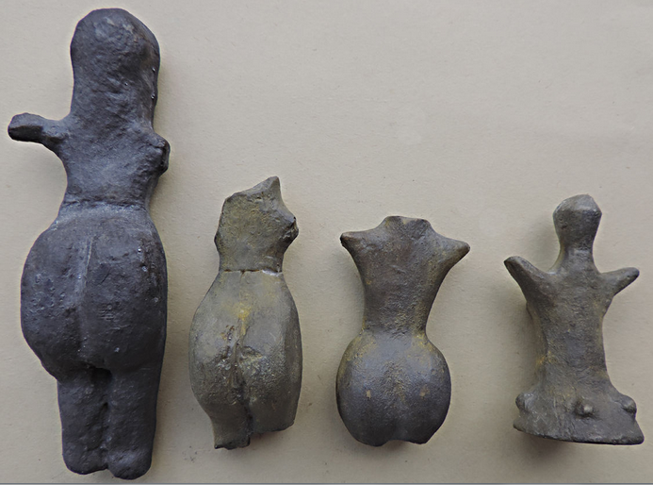 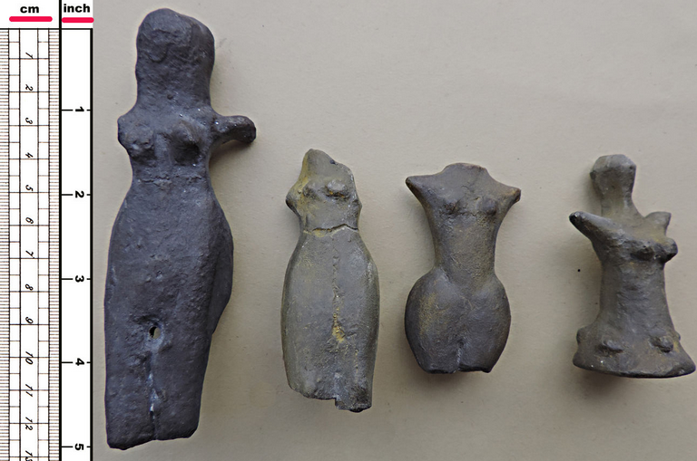

**Size of greatest Venus: 13 cm (5,1 inches).**